MELIORA



**EDITION - 47 | SEPTEMBER 2023**

**© COPYRIGHT 2023 MINDCRAFT SOFTWARE PVT. LTD. ALL RIGHTs REsERVED | FOR EMPLOYEEs ONLY**





# EDITORIAL

**© COPYRIGHT 2023 MINDCRAFT SOFTWARE PVT. LTD. ALL RIGHTs REsERVED | FOR EMPLOYEEs ONLY**

Dear Friends,

Welcome to the infinite expanse of the cosmos!

In this celestial journey, we will embark on a thrilling exploration of our MindCraft universe. From distant galaxies to mysterious black holes, our amateur astronomers are here to spark your curiosity about the wonders of space. Join us as we navigate the cosmos, uncovering the secrets of the universe one star at a time. Get ready to be inspired by the beauty and vastness of space right here in this edition.

In this edition of Meliora, we deliver to you quarterly updates from across various departments of MindCraft, so stay up-to-date with all the information and take a few moments to cheer our growth.

In Inner Mind, we are excited to help you acquaint yourselves with Shagufta Sheikh our Project Manager.

In the Team Focus section, we have featured our Patching Team at IDFC. In Perspectives & Perceptions, you will get to know more about our employees’ thoughts on space which we have compiled through the poll we had recently conducted.

We have covered all the fun events that happened in the months of July, August and September that you wouldn't want to miss.

With this, we end the quarter filled with fun, joy, and memories. Hope we keep making memories for the rest of the year. Do read this edition and share your valuable feedback for us to keep improving.

Take care of your health and stay safe! Warm regards,

Editorial Team



**© COPYRIGHT 2023 MINDCRAFT SOFTWARE PVT. LTD. ALL RIGHTs REsERVED | FOR EMPLOYEEs ONLY** **03**





# MIND SPEAk

**© COPYRIGHT 2023 MINDCRAFT SOFTWARE PVT. LTD. ALL RIGHTs REsERVED | FOR EMPLOYEEs ONLY**

HEMANT NERURkAR

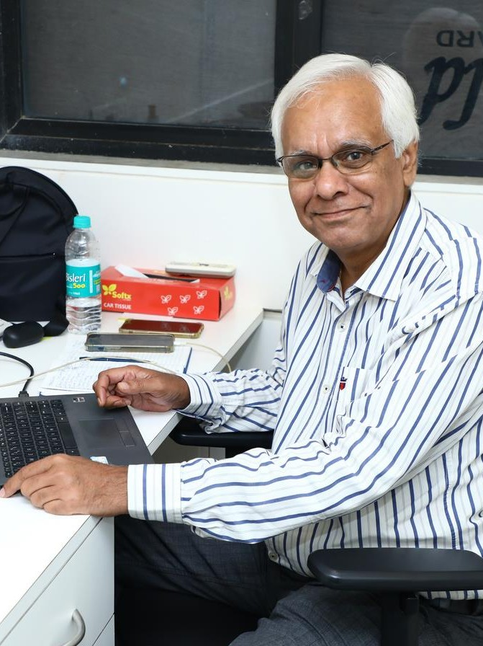

**FOUNDER & PREsIDENT**

As a company, we were incorporated on Sep 13th, 2002. But we started our operations, on Oct 1st. Incidentally, our first purchase order was from KMFL, (was before it was Kotak Bank)!

There were many customers who had issues transferring the POs from our previous organization to our new entity! In some cases, it was easy, while in HDFC Bank and BSE, it wasn’t easy. But we managed it. We continued servicing for a few months, without billing, it was very difficult, financially! But as long as the founders could manage it, nobody even knew the issue!

These were early days. Why are we where we are today? Recently, HR sent me a report saying that we have 18 people who have been with us for over 10 years. And over 28 people have had a tenure at MindCraft for over 5 years! These statistics made me proud. If you can retain people for this long, they have a sense of belonging. For that, the company has to create an environment that makes them feel valued.

The company must be able to tell the employee that he or she is very important to us! And that’s the way a company retains their employees for a long time. This approach has helped us create a positive workplace culture, fostering collaboration and team spirit. The knowledge of experienced employees helps newer employees learn faster. This in turn has helped us build a conducive environment for employees to thrive and grow in.

The cornerstone of our success is our employee, who is technically good, understands the domain and client business and is hardworking. That’s why we value such employees and commend them.



**© COPYRIGHT 2023 MINDCRAFT SOFTWARE PVT. LTD. ALL RIGHTs REsERVED | FOR EMPLOYEEs ONLY** **05**





# INNER MIND

**© COPYRIGHT 2023 MINDCRAFT SOFTWARE PVT. LTD. ALL RIGHTs REsERVED | FOR EMPLOYEEs ONLY**

SHAgUFTA SHEIkH

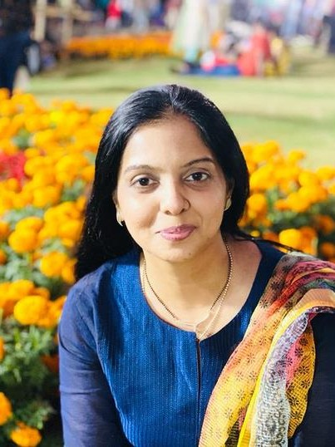

**PROjECT MANAgER**

* Three words that describe you the best?

Calm, Cordial and Polite.

* What's your favourite fact or discovery about space that never fails to amaze you?

There are 79 known moons orbiting Jupiter. Jupiter is the planet in our solar system with the most moons, and it also has the largest moon in our solar system.

* **In the spirit of space exploration, what's the most innovative idea or initiative you've witnessed?** Chandrayaan-3 was a gigantic success for India. Every Indian is proud of the soft landing of Chandrayaan-3 on the moon!
* If you had the chance to travel to space, what's one thing you'd love to do or experience?

Considering the current technology development and exorbitant cost incurred, it would be a memorable experience in my life to travel to space. I would like to do something that can’t be done on earth. Every night I see it shining brightly in the sky. It’s a truly beautiful sight. If I had the chance, I would like to go for a walk on the moon.

* One quote you live by.

“Don’t be pushed by your problems. [Be led by your dreams](https://thestrive.co/best-go-for-your-dream-quotes/).”

– Ralph Waldo Emerson

* What do you consider to be your biggest achievement in your professional career?

I have been working for corporates in the Banking and Insurance domain and have been part of the project team for many years. Gradually I developed an interest and desire to work for an IT company and joining Mindcraft has helped me to work for one. My greatest achievement is that I have been promoted and aligned to different projects due to my consistency in work deliverables, self-motivation, and desire for learning. Which I think is an achievement in itself.

* How do you motivate yourself on the hardest days?

[Remember your “why,” and stay focused on your purpose](https://www.bing.com/ck/a?!&&p=40f874a72fdf443dJmltdHM9MTY5NDU2MzIwMCZpZ3VpZD0zZWMzYTU4Yi01ZmU2LTZjN2YtM2E3Yi1iN2FkNWU1NDZkNzYmaW5zaWQ9NTcwNQ&ptn=3&hsh=3&fclid=3ec3a58b-5fe6-6c7f-3a7b-b7ad5e546d76&psq=7.%09How%2Bdo%2Byou%2Bmotivate%2Byourself%2Bon%2Bthe%2Bhardest%2Bdays&u=a1aHR0cHM6Ly93d3cuaW5kZWVkLmNvbS9jYXJlZXItYWR2aWNlL2NhcmVlci1kZXZlbG9wbWVudC90aXBzLWZvci1ob3ctdG8td29yay1oYXJk&ntb=1).



**© COPYRIGHT 2023 MINDCRAFT SOFTWARE PVT. LTD. ALL RIGHTs REsERVED | FOR EMPLOYEEs ONLY** **07**

* + Part of your day that you enjoy the most.

I am an early riser. So, for me, early morning is the most important and pleasant part as I can enjoy it in complete peace and serenity. The tranquillity of the surroundings, soothing temperature, refreshing breeze, and the promise of starting a great day make it worth enjoying. It is said that the morning shows the day and I totally agree with this adage. It helps you to organize your thoughts and tasks for the day. If I can keep away my tensions and start the morning the way I expect it to be, the whole day becomes fruitful and enjoyable.

* + What advice would you give to newcomers looking to make their mark in our organization?

Make a strong first impression. Your first impression will always be your last impression. Spend time with other employees/colleagues/peers. Ask for help, don’t feel shy. Everyone needs help there is nothing to feel bad about it. Schedule time for skill development. Always be open to learning. Participate in internal and external stakeholders’ meetings whenever required. Offer to help others when in need.

* + What hobbies do you have?

Travelling is one of the most rewarding hobbies one can have and I love travelling. Travelling has helped me break out from my routine life and experience new cultures,cuisines, and

traditions. I have explored places like Kolkata, Hyderabad, Kerala, Delhi, Rajasthan, and Maharashtra within my country. I had an opportunity to explore a few other countries as well like Hongkong, Singapore, Malaysia, and UAE and I wish to add more cities and places to this list.

* How do you maintain a healthy work-life balance, and do you have any tips for your colleagues?

I work and coordinate with my colleagues and team on a regular basis and delegate work wherever required and possible. This has helped me to ensure that neither I nor my team is overworked and helped us have a healthy working environment. This in turn helps one to have a healthy work-life balance.

* Who / what inspires you and why?

For married working women, husbands play a pivotal role in their growth and well-being besides their extended families. I have been blessed with a supporting life partner who has always inspired, encouraged, and motivated me. His positive approach towards life’s endeavours is his strength. He has been a strong pillar for me and my family and has helped us to stay together no matter how difficult the situation would have been. His constant support has helped me to take up challenges, face failures with a smile and move on. I am blessed to have him as a life partner who is more of a best friend to me.



**© COPYRIGHT 2023 MINDCRAFT SOFTWARE PVT. LTD. ALL RIGHTs REsERVED | FOR EMPLOYEEs ONLY** **08**





**QUARTERLy UPDATEs**

**© COPYRIGHT 2023 MINDCRAFT SOFTWARE PVT. LTD. ALL RIGHTs REsERVED | FOR EMPLOYEEs ONLY**

**INTERNATIONAL**

**DELIVERY**

**ALLIANCE**

**UPDATEs**

 

This month we bagged a new project from Singlife, a Financial Services Company in Singapore, focusing on Insurance. Singlife was formed by the merger of Aviva Singapore and Singlife to provide technology-enabled solutions and a wide range of products and services, to help consumers control over their financial wellbeing at every stage of their lives.

The objective of our engagement is to migrate Fuse an Enterprise Service Bus from version 6 to version 7 as well as to migrate from on-premises deployment to AWS Cloud. What makes the project challenging and interesting is that Singlife has made multiple attempts to do this migration and have failed to achieve the objective. They have turned to MindCraft to solve the technical issues that they are facing in transition to Fuse 7 on AWS. Currently, a four-person team is working on the project and it’s a short burn 2 months duration project. The knowledge gained on this project will be very helpful to expand our expertise in Enterprise Integration beyond the IBM IIB space where we already have considerable skills and experience.

MindCraft and IBM jointly organized an exclusive event around ‘AI Powered Automation to Improve ROI and Customer Experience’.

The event was held on July 14th at Taj Lands End in Bandra. Around 12 senior level IT experts from BFSI along with MindCraft team and IBM team engaged in productive discussions on benefits, issues and challenges in implementing AI based products in their respective organizations.

Based on the success, we intend to organize more such round table discussions with senior level customers.



**© COPYRIGHT 2023 MINDCRAFT SOFTWARE PVT. LTD. ALL RIGHTs REsERVED | FOR EMPLOYEEs ONLY** **10**

**DELIVERY – PROjECTs & MS**



MindCraft takes pride in its track record of successfully delivering some of the industry's most significant projects within the life insurance sector. Throughout our journey, we have accumulated profound domain expertise, establishing ourselves as trusted partners sought after by insurance firms.

We continue to grow our team strength at Kotak Life Insurance with the addition of a BPM Developer, 6 consultants with skills in Java Spring Boot and one each with capabilities in Angular and PL SQL.



Leveraging our strong presence in the insurance industry, we have become the preferred technology partner for a multitude of insurance companies. Over the years, MindCraft has executed numerous successful projects for Reliance Nippon Life Insurance.

This quarter our team at Reliance Nippon Life Insurance has grown further with the addition of 2 consultants with skills in ASP.Net Web API, and one each with skills in .NET Web API, Java/J2EE and Manual Testing.



**© COPYRIGHT 2023 MINDCRAFT SOFTWARE PVT. LTD. ALL RIGHTs REsERVED | FOR EMPLOYEEs ONLY** **11**

### DELIVERY – Cs

Technology plays a pivotal role in banking by automating routine tasks, streamlining processes, and reducing operational costs, ultimately enhancing efficiency. MindCraft has been working with leading private banks by providing them various technology services to help them achieve their business goals.

This quarter, at Axis Bank, we have added 3 consultants with skills in ASP.Net Web API, Java/J2EE and PHP Development. A consultant with expertise in Sharepoint has joined our team at DBS Bank, while at HDFC Bank, a consultant with experience in Application Support and another with Manual testing capabilities has joined our current team.

We have increased our team size at ICICI Bank with the joining of 2 WAS Admin consultants, and 2 others with skills in PL SQL and SAS respectively. While at Ratnakar Bank, a Manual Tester has joined our team, at Yes Bank, 2 consultants have joined our team with skills in IIB Development and Tableau.

Insurance companies rely on software solutions and services to streamline underwriting, claims processing, and customer service, resulting in cost savings, quicker response times, and improved customer satisfaction. In the insurance space, we have recently added a Production support consultant at HDFC Ergo General Insurance and a Manual Tester at SBI Life Insurance. While at TATA AIA, 2 consultants with skills in Node.js and one with PL SQL capabilities has joined our team.

At ICICI Prudential AMC, this quarter a consultant with PL SQL skills has joined our team. A consultant with capabilities in ASP.Net Web API has started working at ICRA Limited while at L&T Finance an IIB Admin consultant has joined our team. At Kotak Securities and NCDEX,consultants with skills in ASP.Net MVC have joined existing teams.



**© COPYRIGHT 2023 MINDCRAFT SOFTWARE PVT. LTD. ALL RIGHTs REsERVED | FOR EMPLOYEEs ONLY** **12**

### HR UPDATEs

PLATELET DONATION AWARENEss DRIVE

In the month of July, we arranged a Platelet Donation

Awareness Drive in our office which was held by the team of TATA Memorial Centre. This session was an attempt to propagate the importance of platelet donation for cancer patients.

KNOW YOUR POLICY

We arranged a session on “Know your Policy (GMC & GPA)” which was by the team of Aditya Birla Insurance Brokers Ltd. (ABIBL) to explain the insurance policies in detail.

INDEPENDENCE DAY

In the month of August, we celebrated 77 years of Indian Independence in office with great enthusiasm. What can be a better way to celebrate Independence Day than with the inclusion of each & everyone with lots of fun & games. The dress code was traditional attire in any color of the Indian flag.

Our office was decorated with balloons and flags which was impactful in channelizing the essence of independence.

We started the celebration by singing our National Anthem followed by some delicious snacks. We then played a game called Musical Housie. Each participant was given a blank chit; 38 songs were presented on the slide; each participant had to select 12 songs & write on their respective chit.

The songs were played one by one. The participants were supposed to guess the song & if that song was present on the chit, they had to strike it off. This way 3 full houses were awarded. We had 3 winners.

Winners of the game:

1. Pradnya Londhe
2. Snehalata Anchan
3. Harshita Sharma

Best dressed females:

1. Reema Halder
2. Snehlata Anchan



**© COPYRIGHT 2023 MINDCRAFT SOFTWARE PVT. LTD. ALL RIGHTs REsERVED | FOR EMPLOYEEs ONLY** **13**

Best dressed males:

* 1. Akash Latake
  2. Bhasker Donakonda

### HR UPDATEs

BRINg YOUR KIDs TO WORk DAY

On 9th September, we organized ‘Bring your Kids to Work Day’.

It was a day filled with fun, frolic, laughter & joy. All the kids

CHANDRAYAAN-3

To celebrate the successful soft-landing of Chandrayaan-3 on the moon's surface on 23rd August 2023, we relished lip- smacking snacks in the office. Congratulations, India!

TRAININgs

In this quarter, we carried out the following training sessions – Core Java, HTML, CSS & Java Scripting, Hibernate, Spring Core, MVC and Spring Boot with Microservices, Angular, Azure Data Factory, OS & Linux Training, Information Security Awareness Training, Business Communication & Email Etiquette, PLSQL Training, and Linux Administration with Troubleshooting skills.

AWARDs

We felicitated employees with quarterly (AMJ’23), half-yearly performance (JFM-AMJ'23) & service awards.

enjoyed fun activities arranged for them with lots of exciting gifts, followed by a scrumptious meal.

INCORPORATION DAY

On 13th September, MindCraft turned 21!!

We celebrated our incorporation day by serving joy through a

‘Live Chaat Counter’.

BIRTHDAY CELEBRATIONs

We celebrated the birthdays of employees born in July, August and September.



**© COPYRIGHT 2023 MINDCRAFT SOFTWARE PVT. LTD. ALL RIGHTs REsERVED | FOR EMPLOYEEs ONLY** **14**





# AWARDs

**© COPYRIGHT 2023 MINDCRAFT SOFTWARE PVT. LTD. ALL RIGHTs REsERVED | FOR EMPLOYEEs ONLY**

###### QUARTERLY PERFORMANCE AWARDs – AMJ 2023

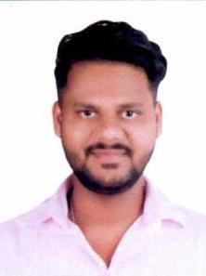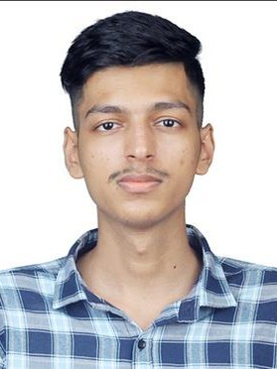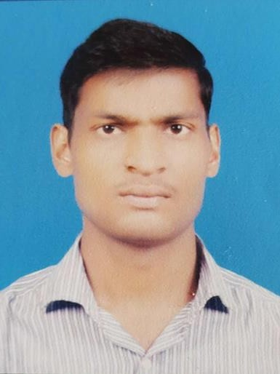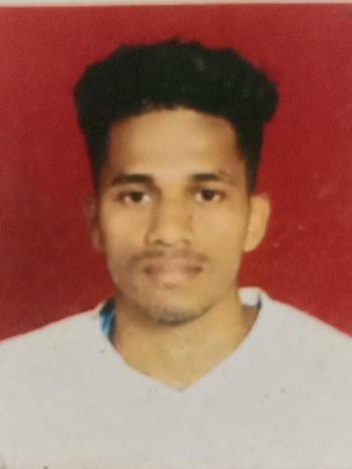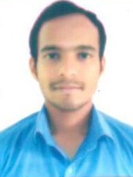

**AAkAsH KHANDAgALE**

**Senior Consultant, Consulting Services**

**ABHIsHEk UPADHYAY**

**Consultant, Consulting Services**

**AkHILEsH YADAV**

**Senior Consultant, Consulting Services**

**AksHAY RAMANI**

**Consultant,**

**Projects & Managed Services**

**AksHAY GHEgADMAL**

**Senior Consultant, Projects & Managed Services**

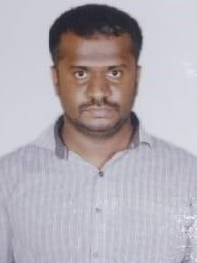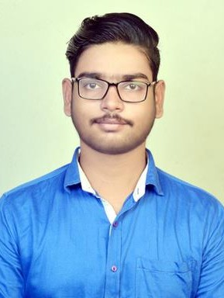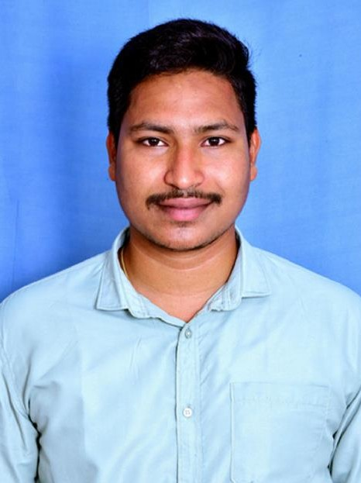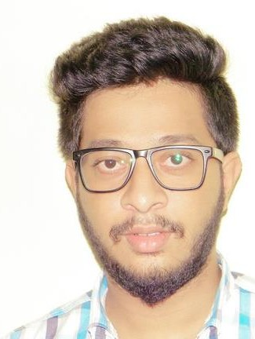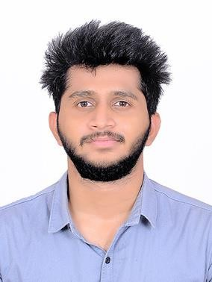

**ANjANA MURTHY V**

**Senior Consultant,**

**Consulting Services**

**ANkIT JHA**

**Associate Consultant, Projects & Managed Services**

**BAsURI KUMAR**

**Senior Consultant, Projects & Managed Services**

**EsHWAR ANUMALLA**

**Associate Consultant, Projects & Managed Services**

**HRIsHIkEsH MUDAYE**

**Associate Consultant, Projects & Managed Services**

**© COPYRIGHT 2023 MINDCRAFT SOFTWARE PVT. LTD. ALL RIGHTs REsERVED | FOR EMPLOYEEs ONLY** **16**

###### QUARTERLY PERFORMANCE AWARDs – AMJ 2023

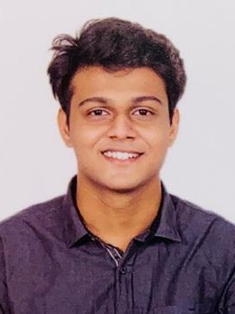

**JAY TARkAR**

**Consultant, Consulting Services**

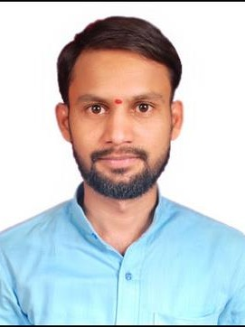

**KAILAs GAIkWAD**

**Senior Consultant, Projects & Managed Services**

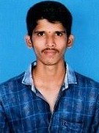

**KIRAN MANE**

**Associate Consultant, Projects & Managed Services**

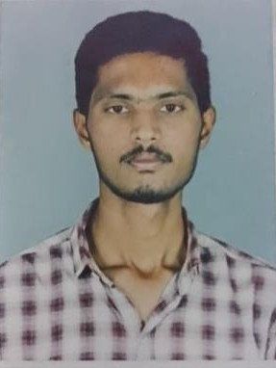

**P PALADEEP REDDY**

**Consultant, Projects & Managed Services**

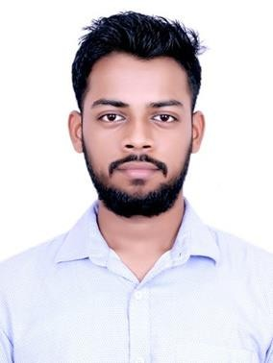

**PARAg IYYANI**

**Consultant, Projects & Managed Services**

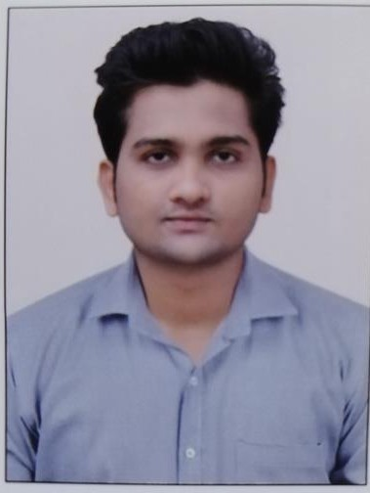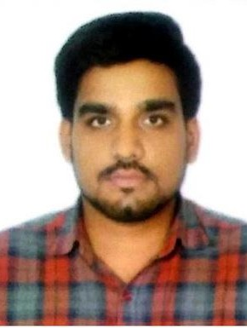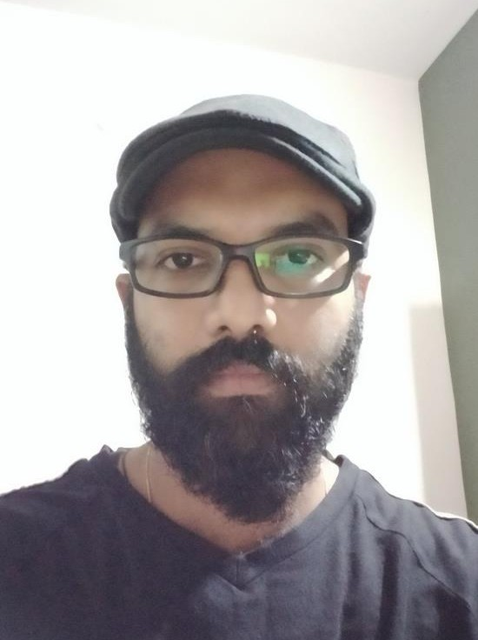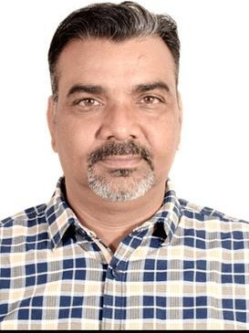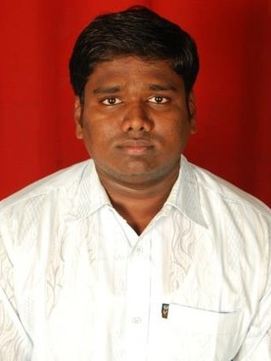

**PRITAM TURALkAR**

**Associate Consultant, Consulting Services**

**PUNIT PANDEY**

**Consultant, Consulting Services**

**RAjEsH SANgHANI**

**Business Analyst,**

**Consulting Services**

**RAMEsH SHARMA**

**Technical Lead, International Delivery**

**SHAILEsH NANAWARE**

**Senior Consultant, Consulting Services**

**© COPYRIGHT 2023 MINDCRAFT SOFTWARE PVT. LTD. ALL RIGHTs REsERVED | FOR EMPLOYEEs ONLY** **17**

###### QUARTERLY PERFORMANCE AWARDs – AMJ 2023

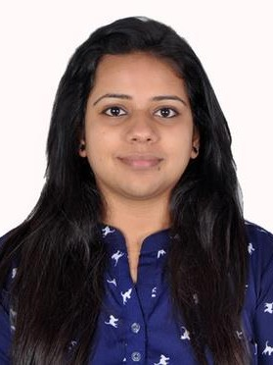

**SURABHI DEsHkAR**

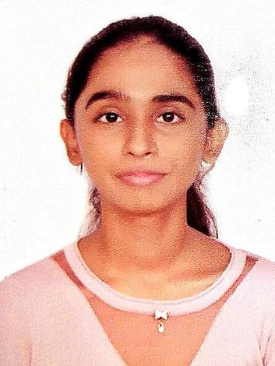

**Senior Consultant, Projects & Managed Services**

**TAHsIN SHAH**

**Associate Consultant, Consulting Services**

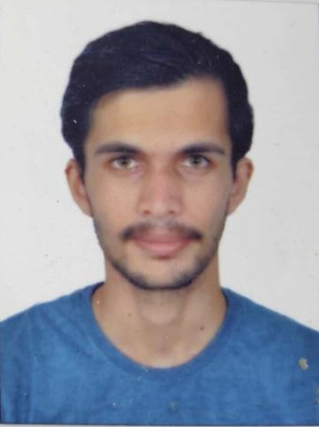

**VIPUL BORHADE**

**Consultant, Projects & Managed Services**

###### PROMIsINg NEWCOMER AWARDs

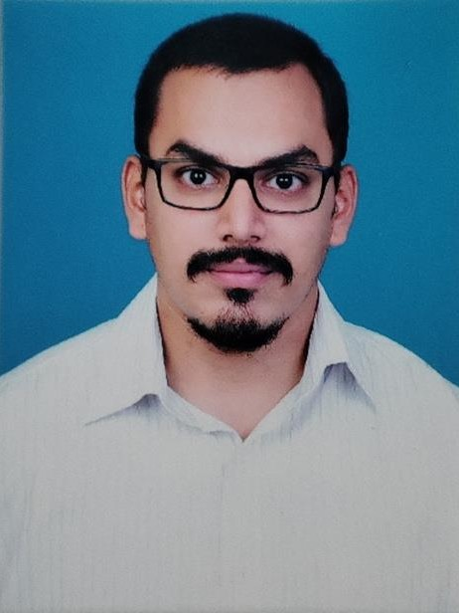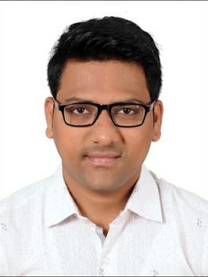

**ABHIsHEk KADUPATIL**

**Consultant, Projects & Managed Services**

**ABHIVYAkTI TRIPATHI**

**Senior Consultant, Consulting Services**

**AMOL SULE**

**Senior Consultant, Projects & Managed Services**



**© COPYRIGHT 2023 MINDCRAFT SOFTWARE PVT. LTD. ALL RIGHTs REsERVED | FOR EMPLOYEEs ONLY** **18**

###### PROMIsINg NEWCOMER AWARDs

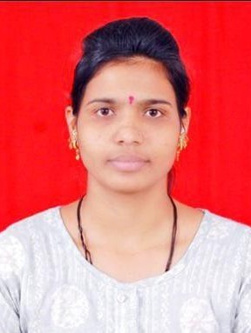

**DEEPALI JADHAV**

**Senior Consultant, Consulting Services**

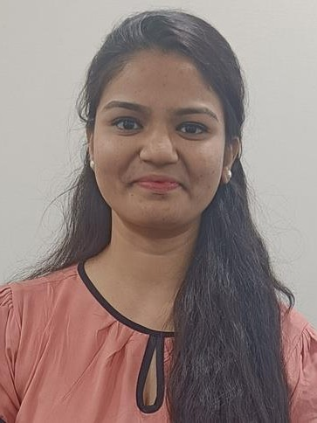

**PRANjAL GAIkWAD**

**Senior Executive, Talent Accquisition**

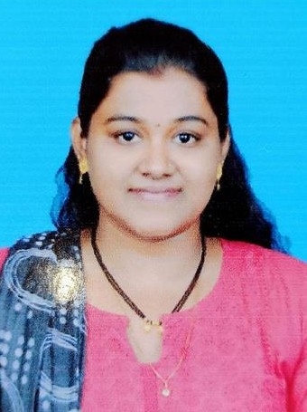

**PRITEE ZANjAD**

**Senior Consultant, Consulting Services**

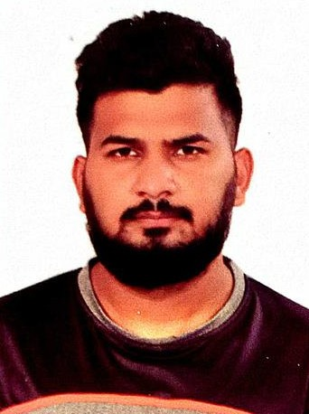

**SACHIN MAURYA**

**Senior Consultant, Consulting Services**

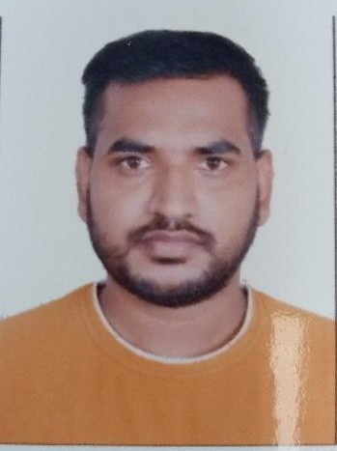

**SHIVAM BHARATI**

**Senior Consultant, Projects & Managed Services**

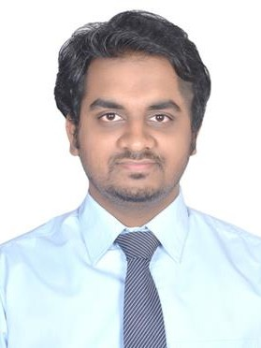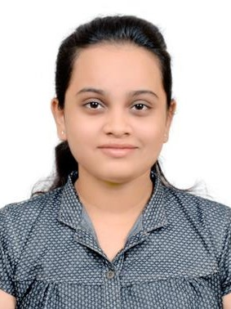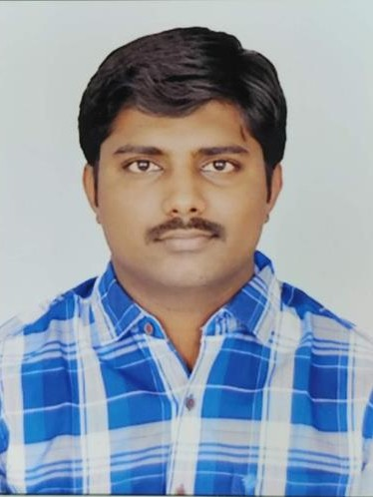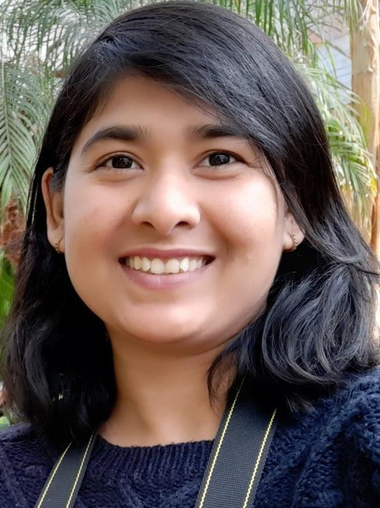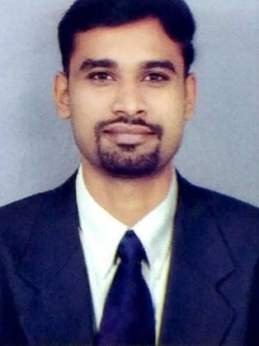

**SHRIkANT SALVI**

**Senior Consultant, Consulting Services**

**SONAL DHAMALE**

**Consultant, Projects & Managed Services**

**VENkATEsH SURAMPALLY**

**Consultant, Projects & Managed Services**

**VIDYA BHOsALE**

**Technical Lead, Consulting Services**

**YOgEsH GHONgADE**

**Senior Consultant, Projects & Managed Services**

**© COPYRIGHT 2023 MINDCRAFT SOFTWARE PVT. LTD. ALL RIGHTs REsERVED | FOR EMPLOYEEs ONLY** **19**

###### RIsINg STAR AWARD

**– AMJ 2023**

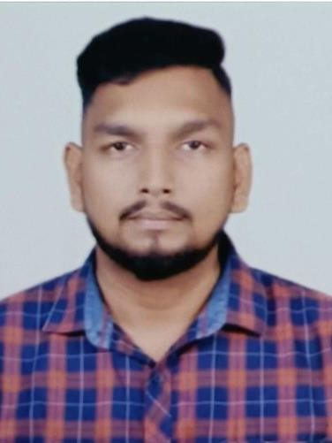

###### HALF YEARLY PERFORMANCE AWARD jFM-AMj 2023

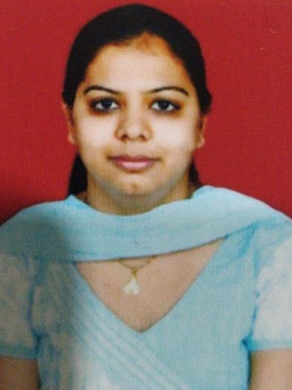

**SAMRAT PARAB**

**Associate Consultant, Consulting Services**

**RAVNEET KAUR NAgPAL**

**Lead Business Analyst, Projects & Managed Services**



**© COPYRIGHT 2023 MINDCRAFT SOFTWARE PVT. LTD. ALL RIGHTs REsERVED | FOR EMPLOYEEs ONLY** **20**





# TEAM FOCUs

**© COPYRIGHT 2023 MINDCRAFT SOFTWARE PVT. LTD. ALL RIGHTs REsERVED | FOR EMPLOYEEs ONLY**



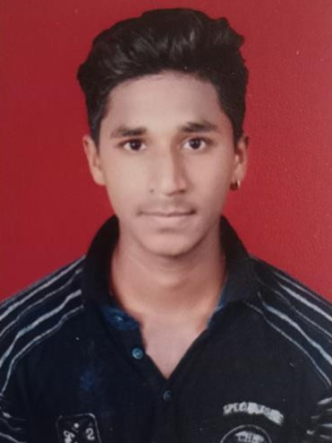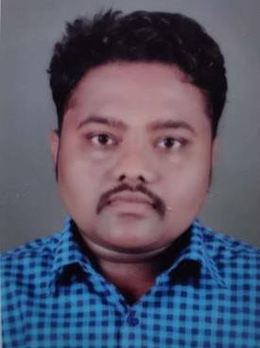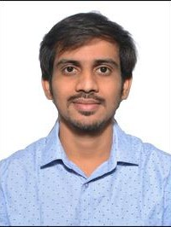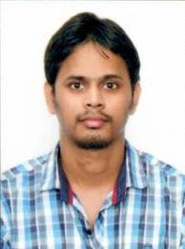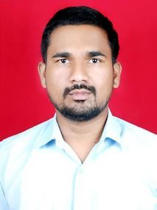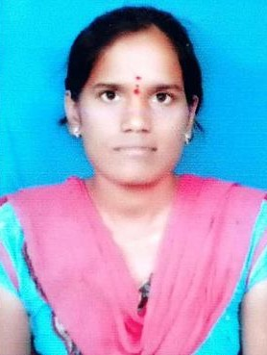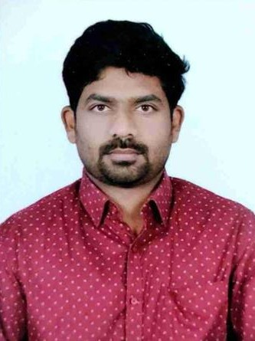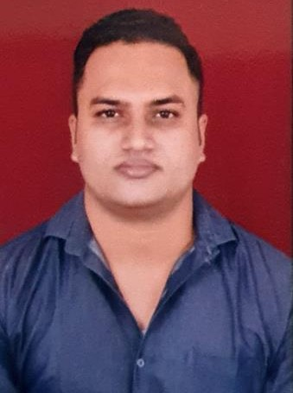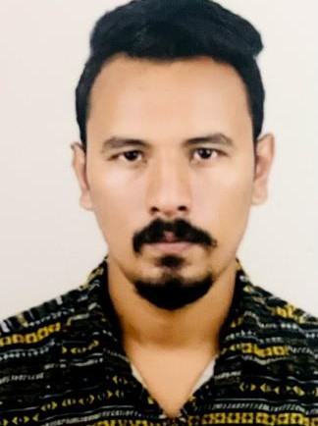

|  |  |  |  |  |  |  |  |  |
| --- | --- | --- | --- | --- | --- | --- | --- | --- |
| **AADEsH** | **AjINkYA** | **AjINkYA** | **AkHIL** | **BALAjI** | **BAsWARAjU** | **BHUPATHI** | **CHETAN** | **HARsHAL** |
| **SHIgVAN** | **JADHAV** | **PATIL** | **NAkHAREkAR** | **MORE** | **RAjITHA** | **MAHENDER** | **PATIL** | **RAjPUT** |

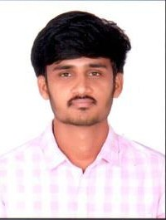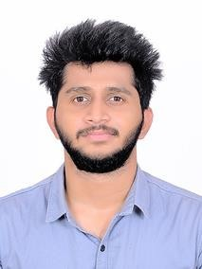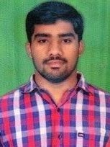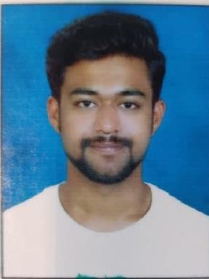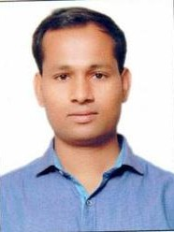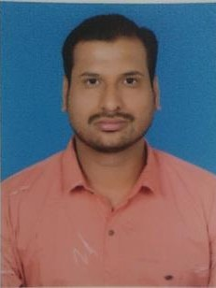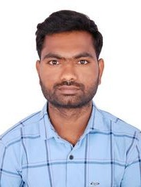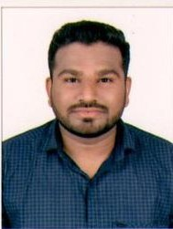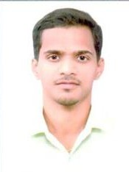

|  |  |  |  |  |  |  |  |  |
| --- | --- | --- | --- | --- | --- | --- | --- | --- |
| **HEMANTH** | **HRIsHIkEsH** | **MALLELA** | **MAYUR** | **NANDkUMAR** | **NIkHIL** | **PALAgIRI** | **PRADIP** | **PRITEsH** |
| **REDDY** | **MUDAYE** | **NAgARjUNA** | **POTE** | **DETHE** | **CHOUDHARY** | **YEDUkONDALU** | **KHATEgHARE** | **CHAVAN** |

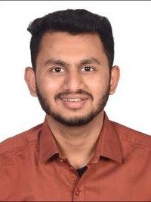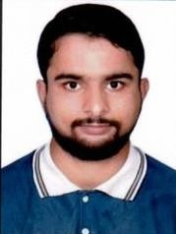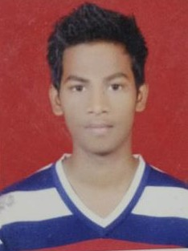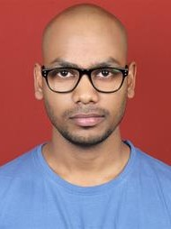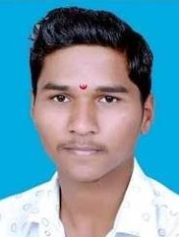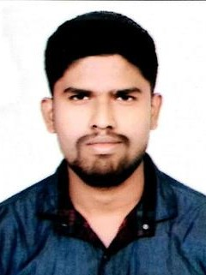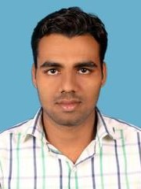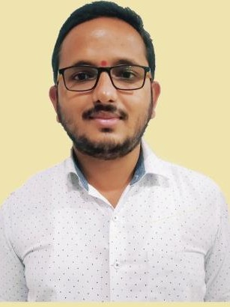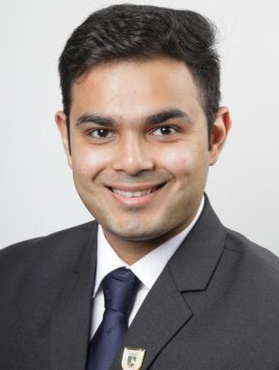

|  |  |  |  |  |  |  |  |  |  |
| --- | --- | --- | --- | --- | --- | --- | --- | --- | --- |
| **RAHUL** | **SAAD ALI** | **SACHIN** | **SHAIk** | **SHAILENDRA** | **SHUBHAM** | **TUsHAR** | **VIPENDRA** | **VIsHAL** | **YUVRAj** |
| **MADHAVI** | **BALBALE** | **NAVIk** | **BABAVALI** | **CHAUHAN** | **PANsARE** | **RAjAPURE** | **YADAV** | **PATIL** | **PARMAR** |

**...and a few others from MindCraft office**

**© COPYRIGHT 2023 MINDCRAFT SOFTWARE PVT. LTD. ALL RIGHTs REsERVED | FOR EMPLOYEEs ONLY** **22**

### IDFC PATCHINg TEAM

Many leading private banks are customers of MindCraft and IDFC Bank is one such customer. The Bank’s strategy is to implant the erstwhile Capital First’s tried and tested model of financing small entrepreneurs and consumers on a bank platform and build on IDFC Bank’s network, excellent technology stack, quality digital banking and strong rural presence. It uses cutting-edge solutions to meet the needs of larger entrepreneurs and corporates and our team is working with the bank to help them achieve their business goals.

We have a team of consultants working on patch management at IDFC First Bank. Our team is responsible for managing patching and closing all open vulnerabilities. Our focus is on managing patching related to OS, Middleware, and Databases. Our team comprises of various skills sets including Project coordinators and consultants with skills in MIS, OS, Databases, Middleware, Network, VMware, Prechecks, SME, Lead and a Process Consultant.

Our non-technical team of project coordinators manages

patching done by our team as well as patching done by other teams within the infrastructure vertical, which are outside the three areas of OS, Middleware and Databases. Besides this, there is a pre-checks team that works on getting on access and prechecks before actual patch execution.

There has been lot of pressure from regulators to close out open vulnerabilities. Our team has put in tremendous effort and is managing more than 45,000 vulnerabilities every month, which is commendable. Despite high pressure situations, they ensure they are serene and find solutions to all issues amicably. The team is hardworking and extremely patient. These are traits that all the team members of this project have, which enable them to deliver this project diligently and efficiently.

In addition to this, our team also work with network and BAU teams in VMware and Network vulnerability management. The pure dedication and commitment to high quality performance of this highly skilled team is indeed commendable.



**© COPYRIGHT 2023 MINDCRAFT SOFTWARE PVT. LTD. ALL RIGHTs REsERVED | FOR EMPLOYEEs ONLY** **23**





**PERsPECTIVEs & PERCEPTIONs**

**© COPYRIGHT 2023 MINDCRAFT SOFTWARE PVT. LTD. ALL RIGHTs REsERVED | FOR EMPLOYEEs ONLY**

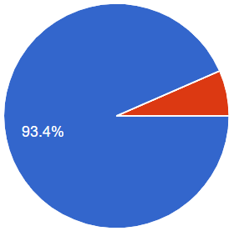Are you interested in space exploration and discoveries?

* **Yes (93.4%)**
* **No (6.6%)**

Do you think space exploration benefits our daily lives on Earth?

* + - 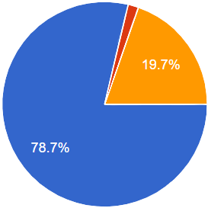**Yes (78.7%)**
    - **No (1.6%)**
    - **Maybe (19.7%)**

What's your favorite space-related fact or trivia?

* 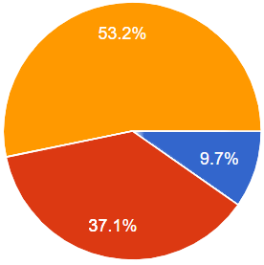**Space is completely silent (9.7%)**
* **The Big Bang Theory (37.1%)**
* **Potential life outside of Earth (53.2%)**

What space-related technological innovation are you most excited

**about?**

* + 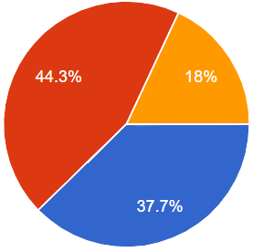**James Webb Space**

**Telescope (37.7%)**

* + **Inter Satellite Link (ISL) Networks (44.3%)**
  + **Others (18%)**

Which recent space mission or discovery has intrigued you the most?

* 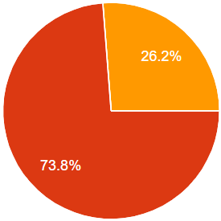**Lucy mission (0%)**
* **Chandrayaan-3 (73.8%)**
* **Aditya L1 (26.2%)**



**© COPYRIGHT 2023 MINDCRAFT SOFTWARE PVT. LTD. ALL RIGHTs REsERVED | FOR EMPLOYEEs ONLY** **25**

Are you aware of the recent discoveries related to exoplanets and the search for habitable worlds?

* 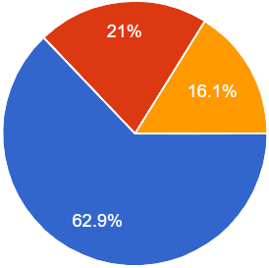**Yes (62.9%)**
* **No (21%)**
* **Maybe (16.1%)**

Do you believe that the potential discovery of extraterrestrial life is imminent, or do you think it's a long way off?

* 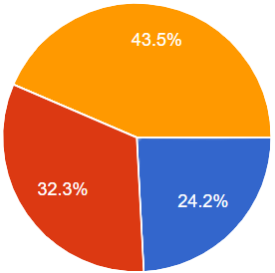**It’s imminent**

**(24.2%)**

* **Long way off (32.3%)**
* **Not sure (43.5%)**

Which space agency or organization do you think is leading the way in space exploration and research?

* 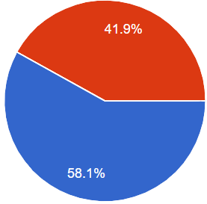**ISRO (58.1%)**
* **NASA (41.9%)**
* **ESA (0%)**

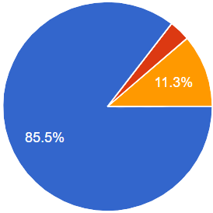Given the opportunity, would you consider participating in a space tourism experience (e.g., suborbital flight)?

* + **Yes (85.5%)**
  + **No (3.2%)**
  + **Maybe (11.3%)**

Have you ever followed a space mission or exploration event in the news?

* 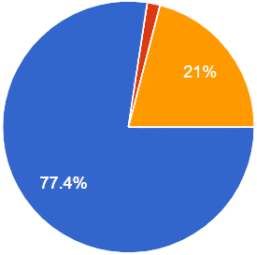**Yes, I have (77.4%)**
* **No, I am not interested (1.6%)**
* **Maybe, at times (21%)**



**© COPYRIGHT 2023 MINDCRAFT SOFTWARE PVT. LTD. ALL RIGHTs REsERVED | FOR EMPLOYEEs ONLY** **26**

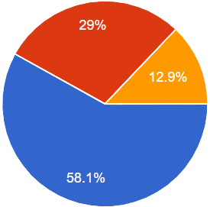What's your favorite space-related movie or TV show?

* **Interstellar (58.1%)**
* **Gravity (29%)**
* **Star Trek (12.9%)**

What do you find most fascinating about space?

* + 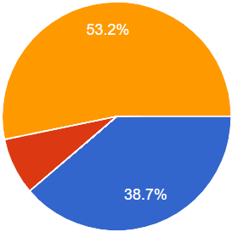**Stars & Planets (38.7%)**
  + **Asteroids and Comets (8.1%)**
  + **Galaxies and Quasars (53.2%)**

What should be the most important priority for space efforts?

* 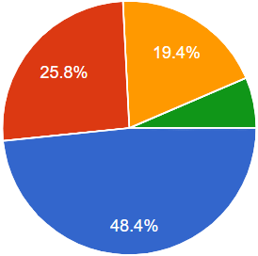**Searching for life and planets that can support life (48.4%)**
* **Searching for raw materials and natural resources that could be used on Earth (25.8%)**
* **Conducting basic scientific**

In your opinion, should space agencies prioritize manned missions to the Moon and Mars over robotic exploration?

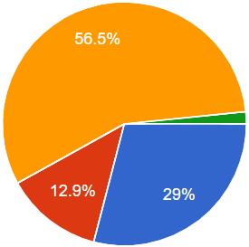

•

•

•

•

**Yes (29%)**

**No (12.9%)**

**It depends (56.5%) I'm not sure (1.6%)**

How concerned are you about the issue of space debris and its potential impact on future space exploration?

* 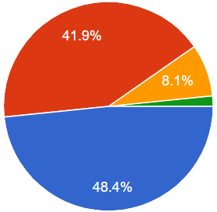**Very concerned (48.4%)**
* **Somewhat concerned (41.9%)**
* **Not very concerned (8.1%)**
* **Not concerned at all (1.6%)**

**research to increase knowledge and understanding of space (19.4%)**

* **Monitoring asteroids and other objects that could potentially hit the Earth (6.5%)**



**© COPYRIGHT 2023 MINDCRAFT SOFTWARE PVT. LTD. ALL RIGHTs REsERVED | FOR EMPLOYEEs ONLY** **27**





## EVENTs AT

**MINDCRAFT**

**© COPYRIGHT 2023 MINDCRAFT SOFTWARE PVT. LTD. ALL RIGHTs REsERVED | FOR EMPLOYEEs ONLY**



#### PLATELET DONATION AWARENEss DRIVE

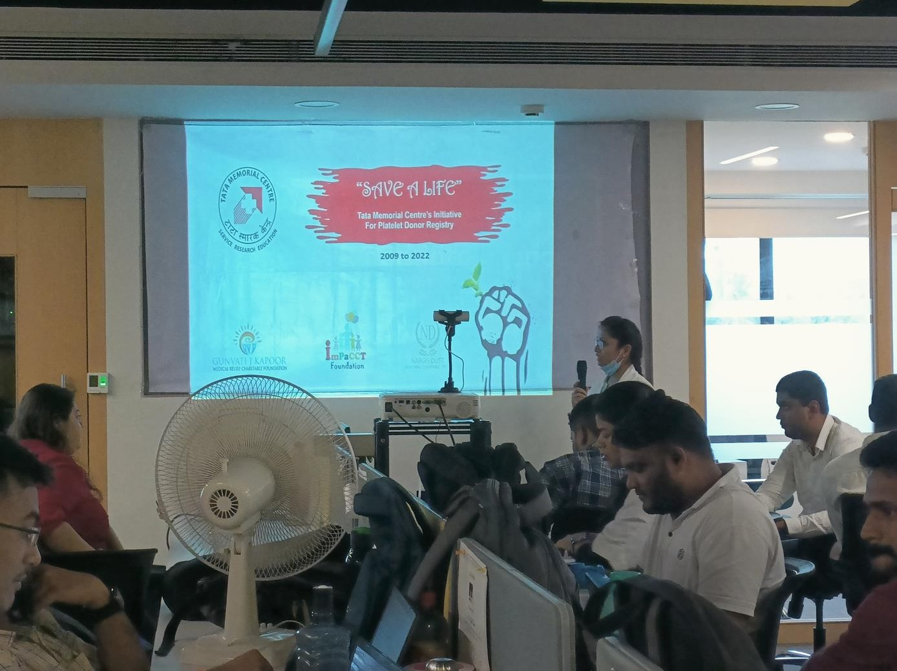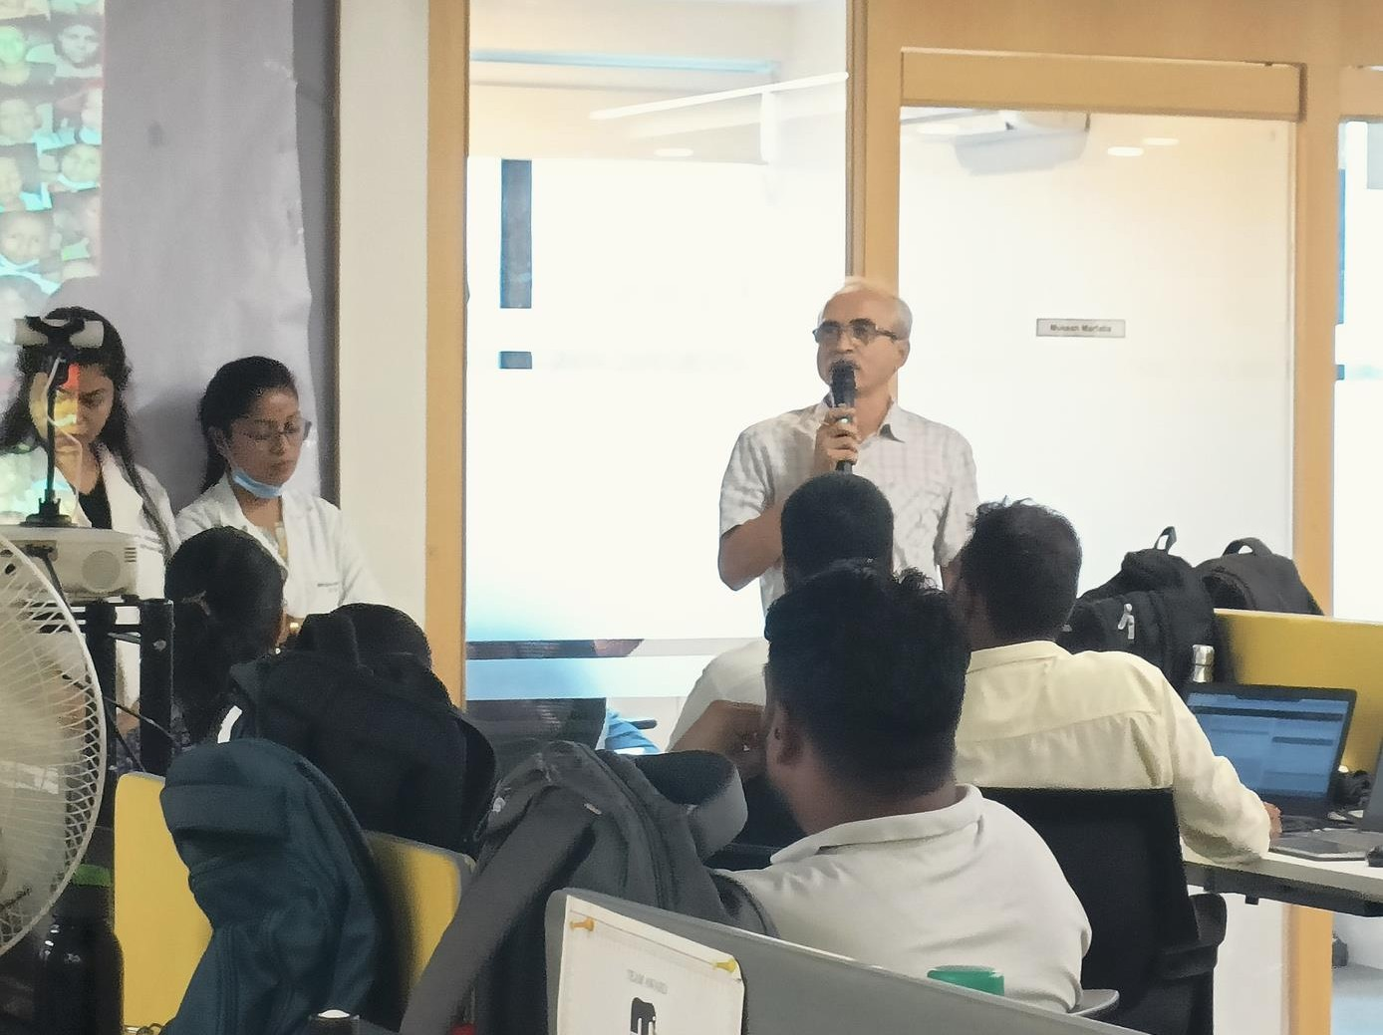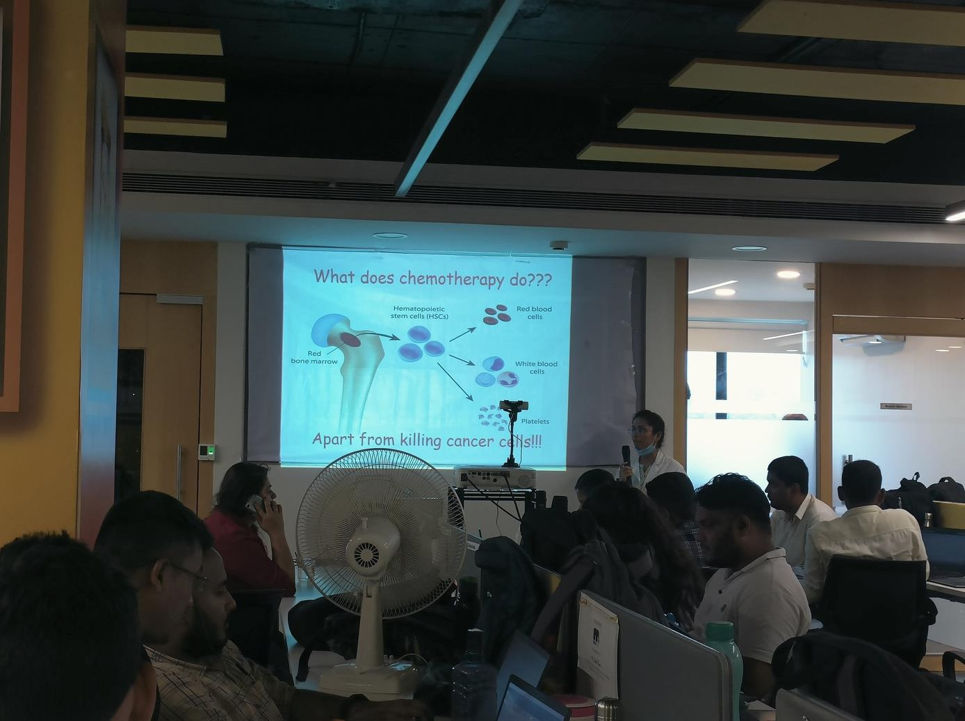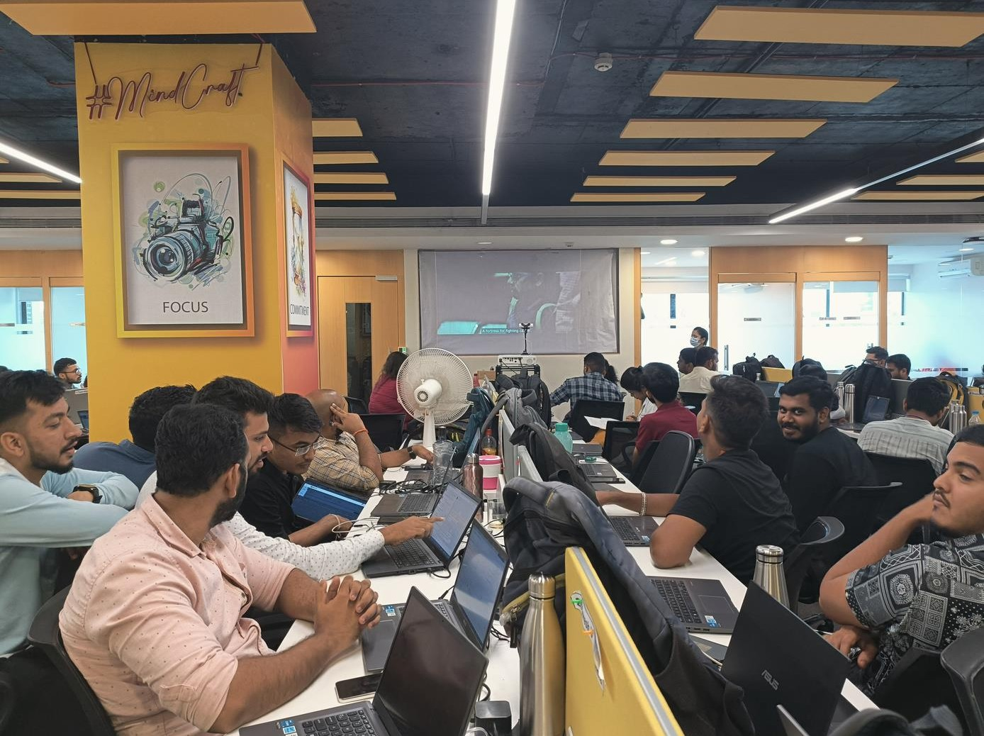

**© COPYRIGHT 2023 MINDCRAFT SOFTWARE PVT. LTD. ALL RIGHTs REsERVED | FOR EMPLOYEEs ONLY** **29**



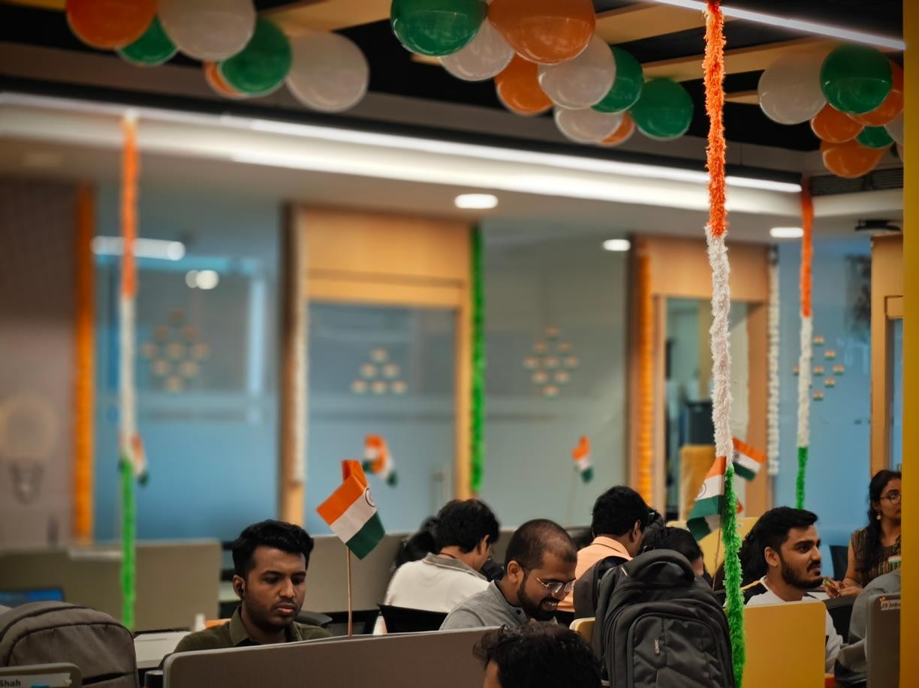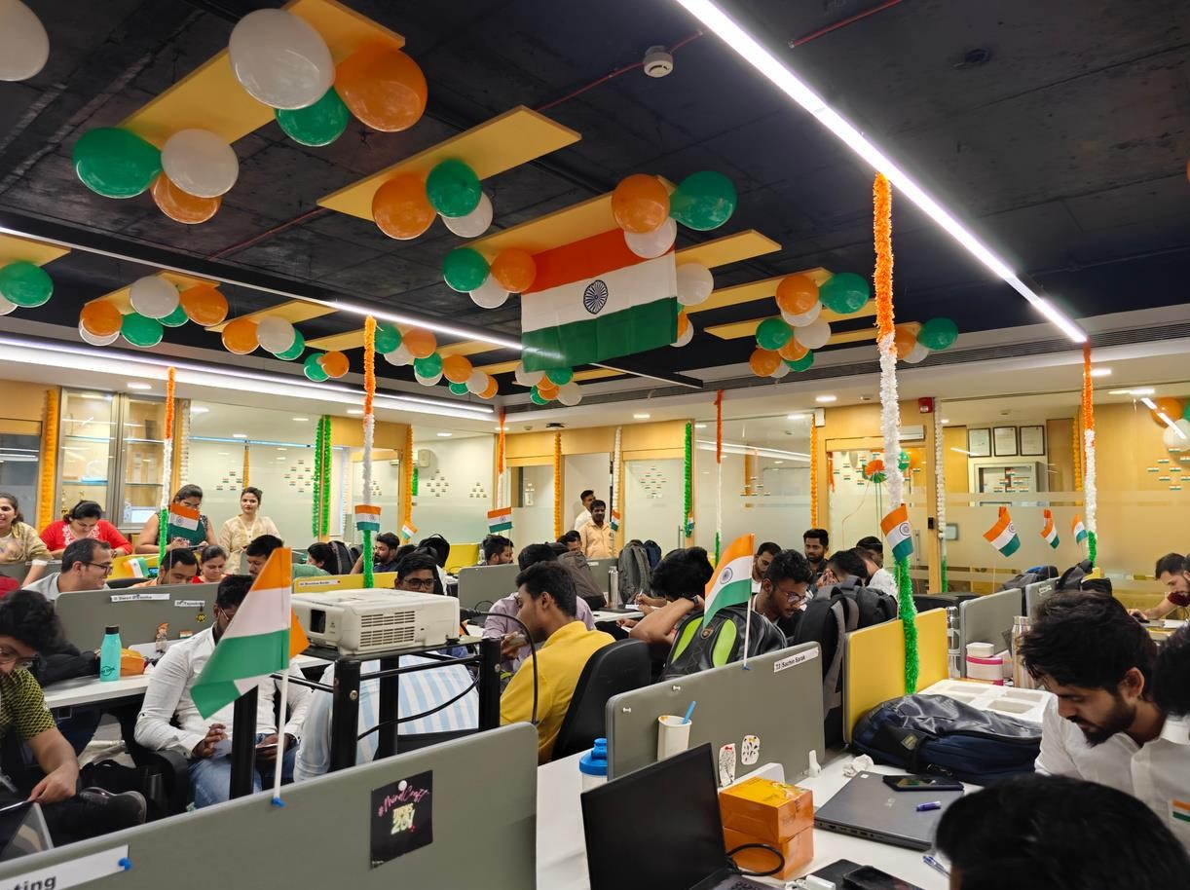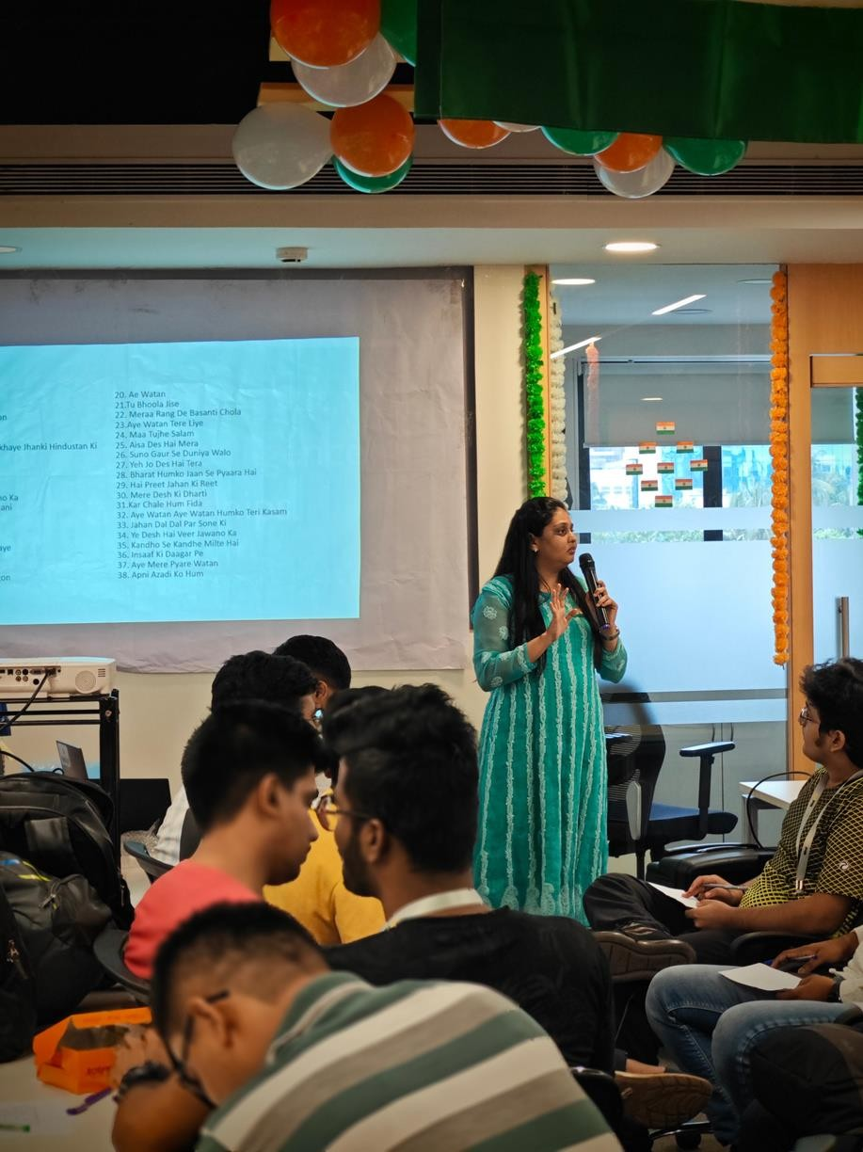

**INDEPENDENCE DAY CELEBRATION**

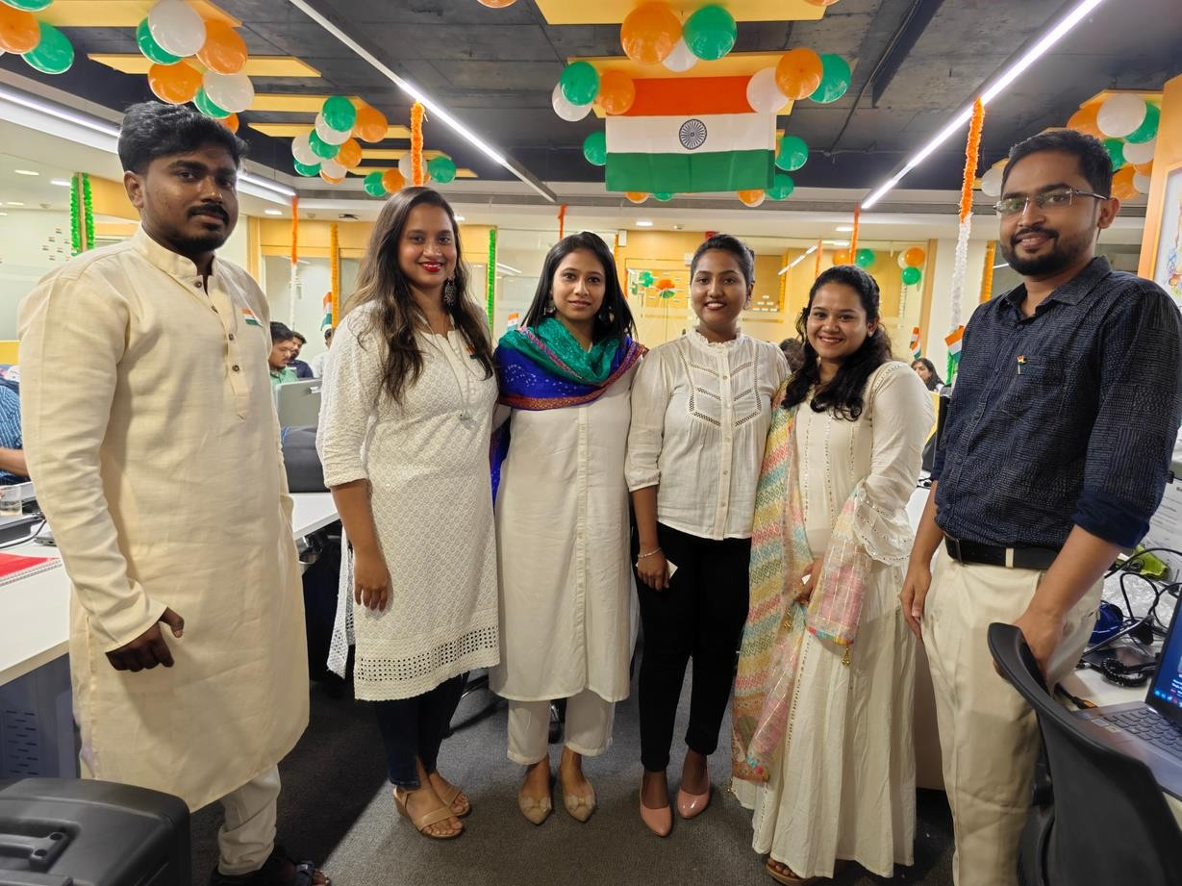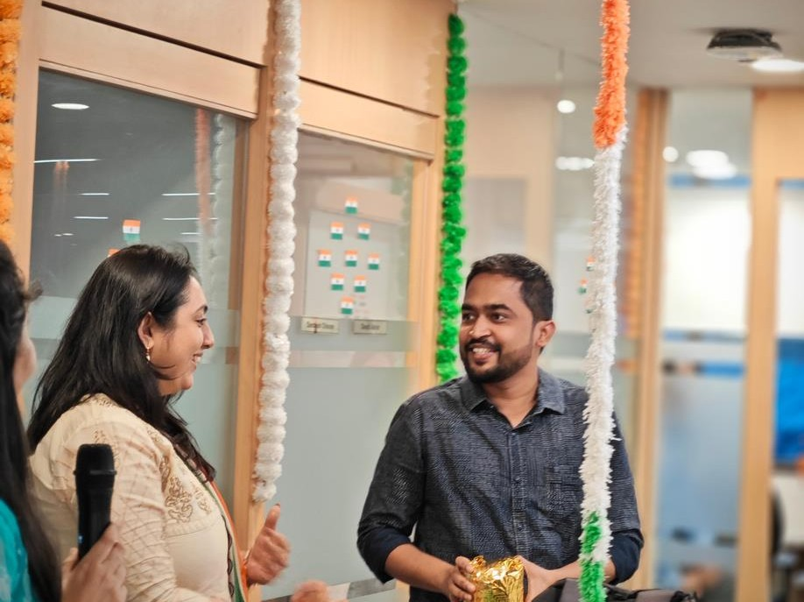

**© COPYRIGHT 2023 MINDCRAFT SOFTWARE PVT. LTD. ALL RIGHTs REsERVED | FOR EMPLOYEEs ONLY** **30**



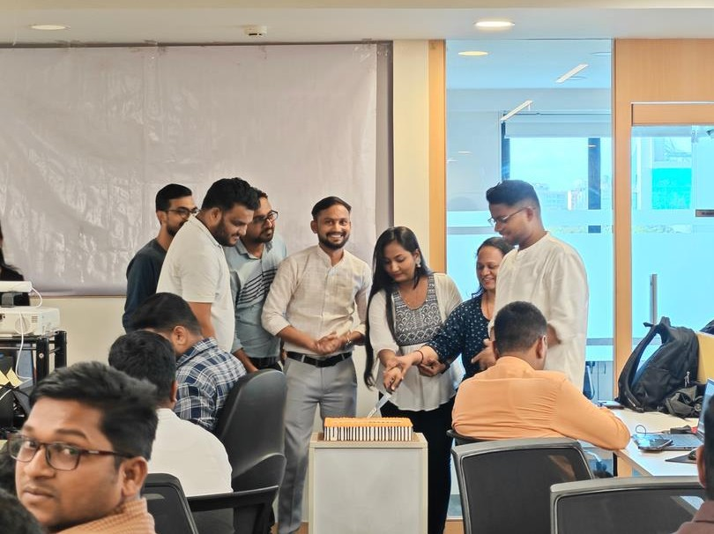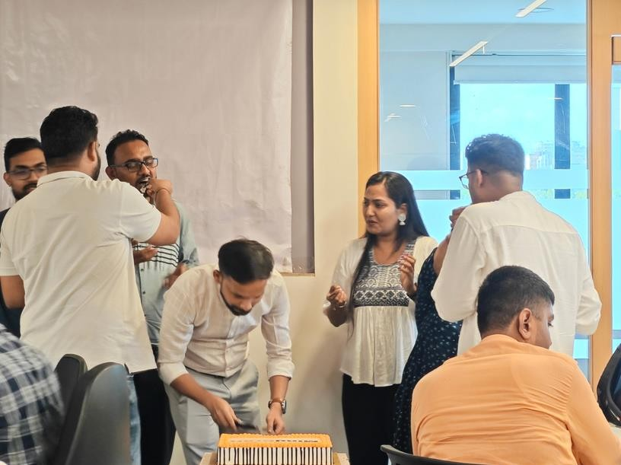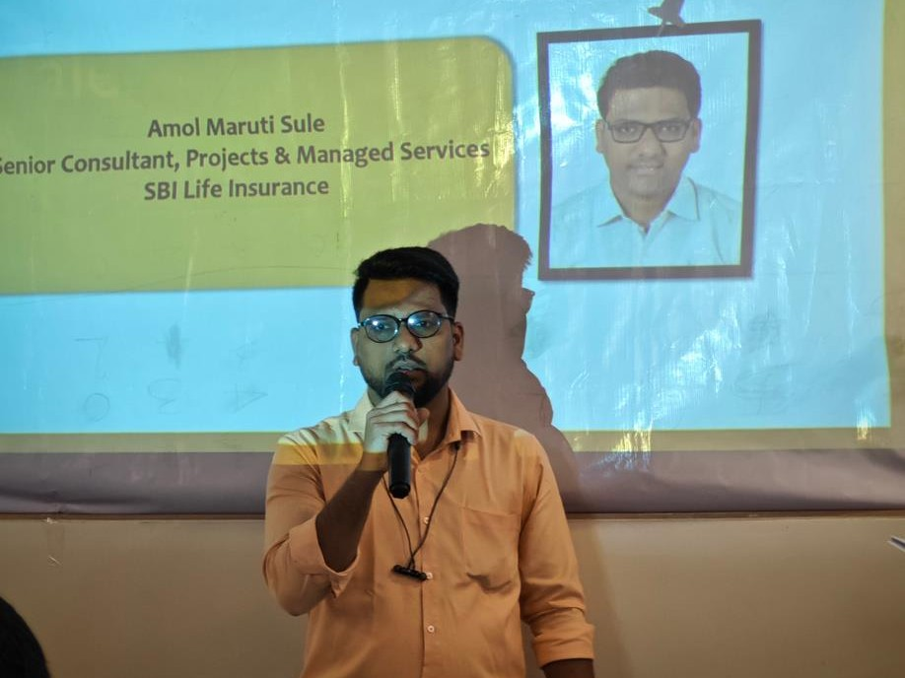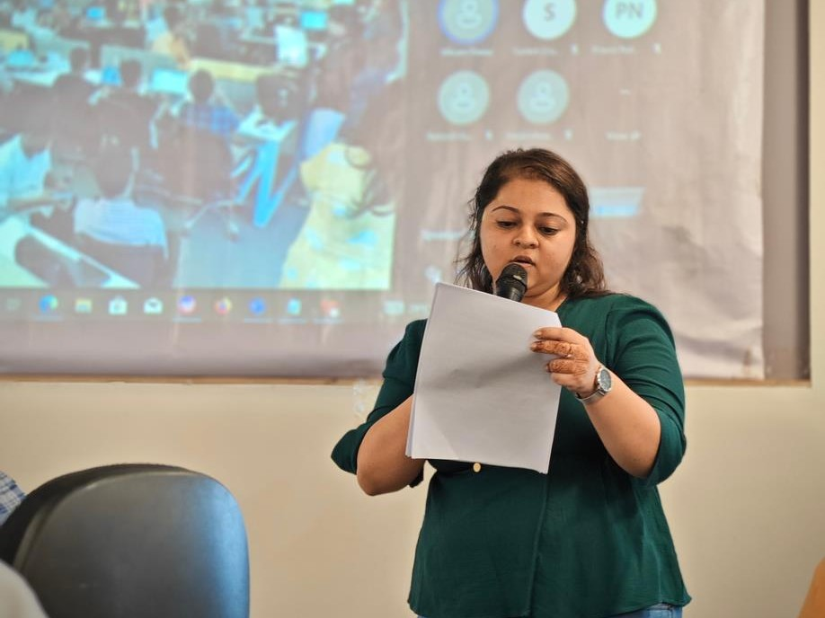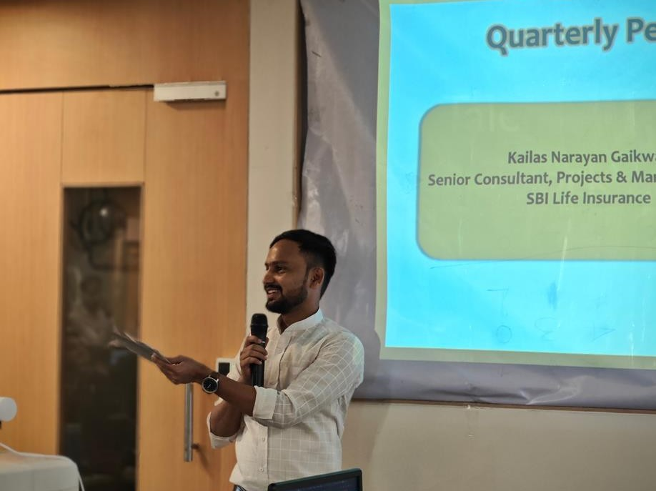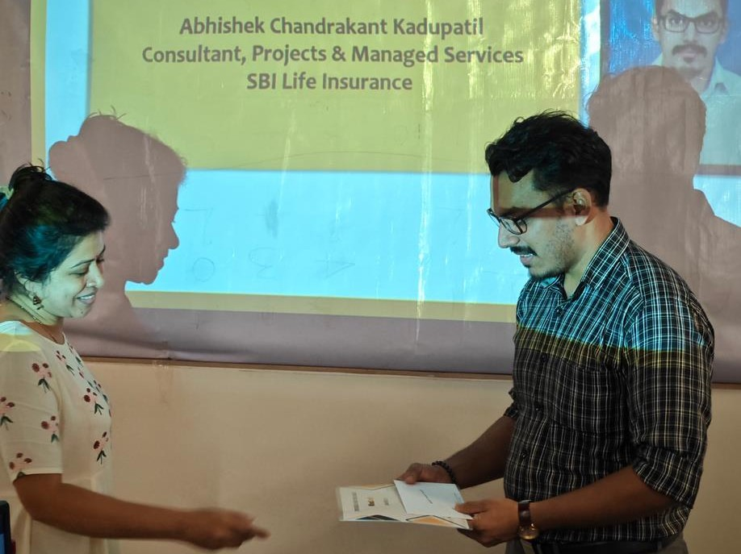

##### BIRTHDAY CELEBRATIONs & AWARDs

**© COPYRIGHT 2023 MINDCRAFT SOFTWARE PVT. LTD. ALL RIGHTs REsERVED | FOR EMPLOYEEs ONLY** **31**

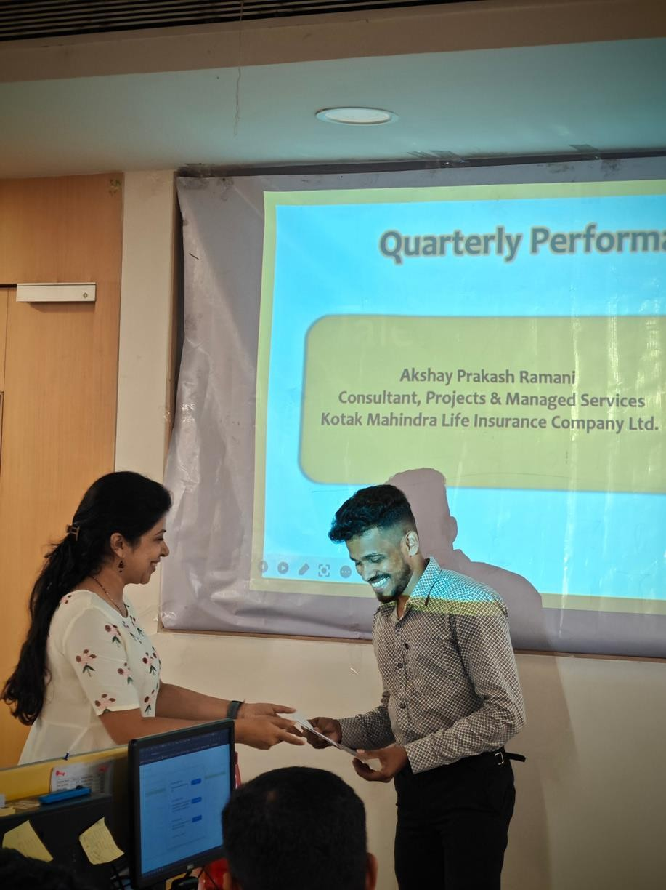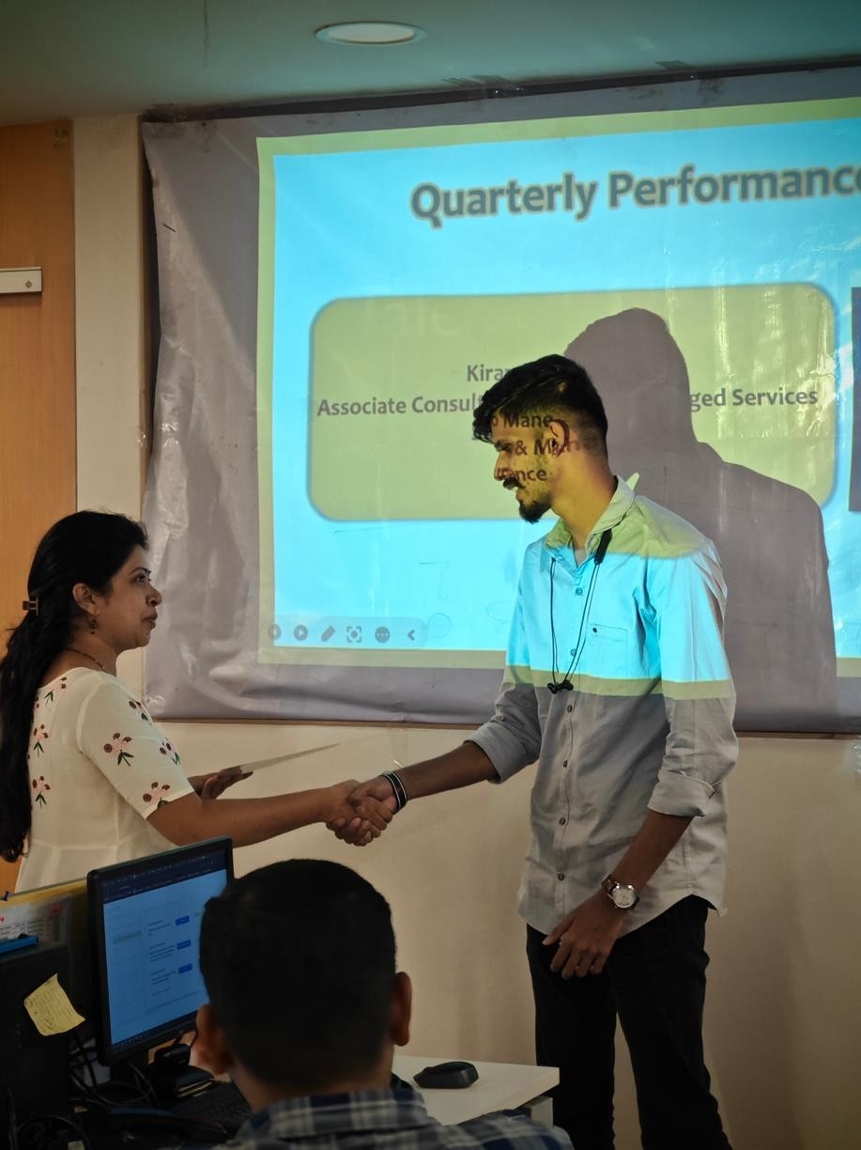



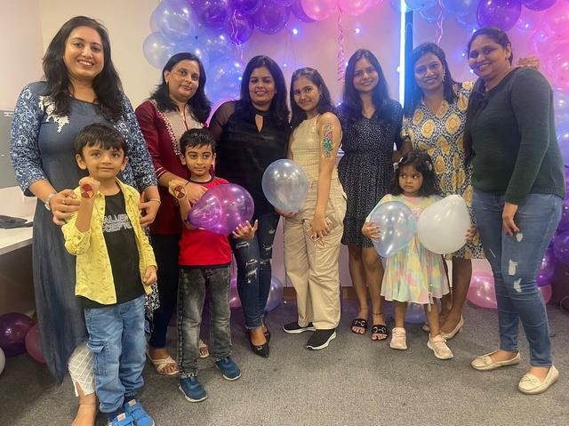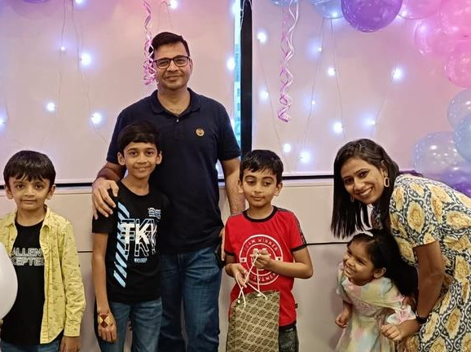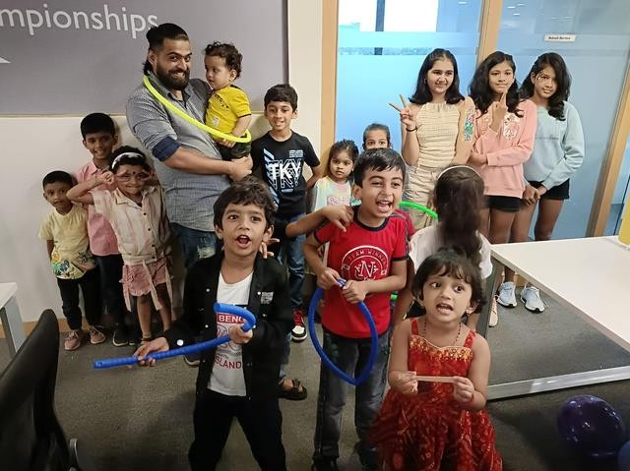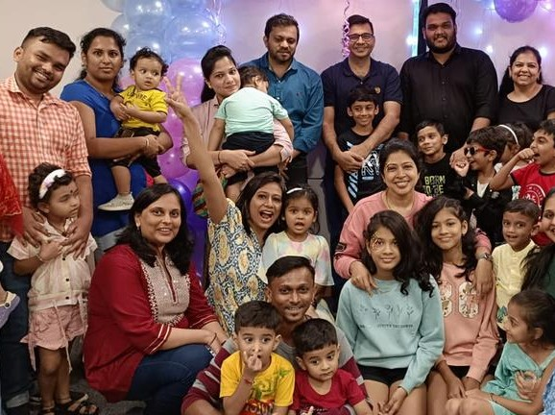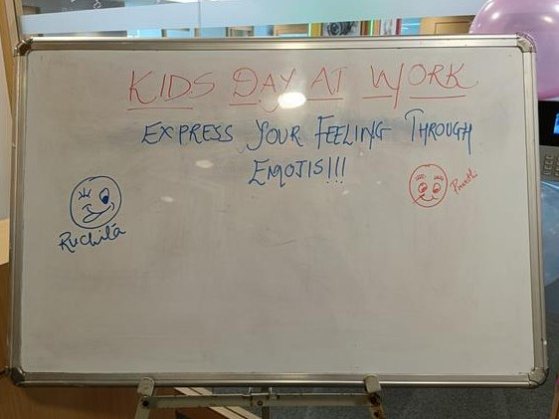

##### BRINg YOUR kIDs TO THE OFFICE DAY

**© COPYRIGHT 2023 MINDCRAFT SOFTWARE PVT. LTD. ALL RIGHTs REsERVED | FOR EMPLOYEEs ONLY** **32**

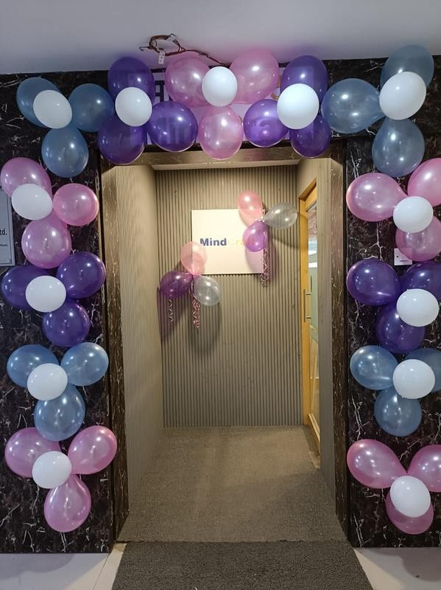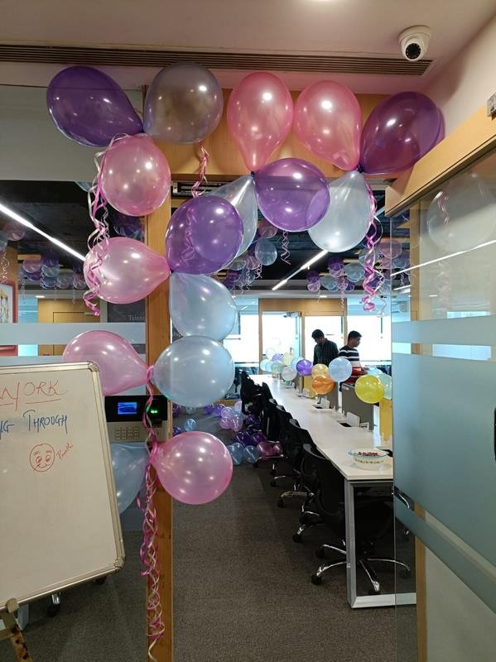

#### ANsWER THE qUEsTION BELOW AND WIN AMAZINg gIFT VOUCHERs

**What percentage of people find Galaxies and**

#### Quasars as most fascinating about space?

**To win gift vouchers, send in your answers to** [**corpcomm@mindcraft.in**](mailto:corpcomm@mindcraft.in) **with the subject ‘Meliora - 47 Master Mind’ The last date for sending your entries is Saturday, 14th October, 2023.**

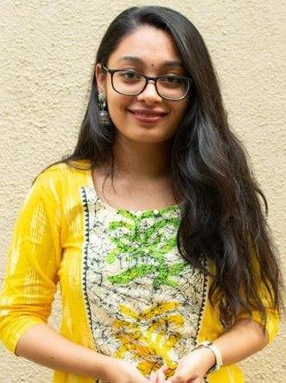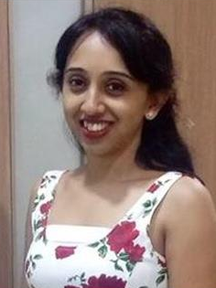

WINNER OF MAsTER-MIND OF EDITION 46

Parag Iyyani

**HAsTI SHAH**

**RAMYA SAHAsRANAMAN**



**© COPYRIGHT 2023 MINDCRAFT SOFTWARE PVT. LTD. ALL RIGHTs REsERVED | FOR EMPLOYEEs ONLY** **33**